Case Study For a Typical Danish Apartment / Flat

This is an example on how OpenTRV could be used in a typical danish flat.

The flat is heated with district heating which is more common here than gas or oil heating. Even private owned houses has it and the trend is to go toward either district heating or solar energy / heat pumps.

A quick run-through of the system:

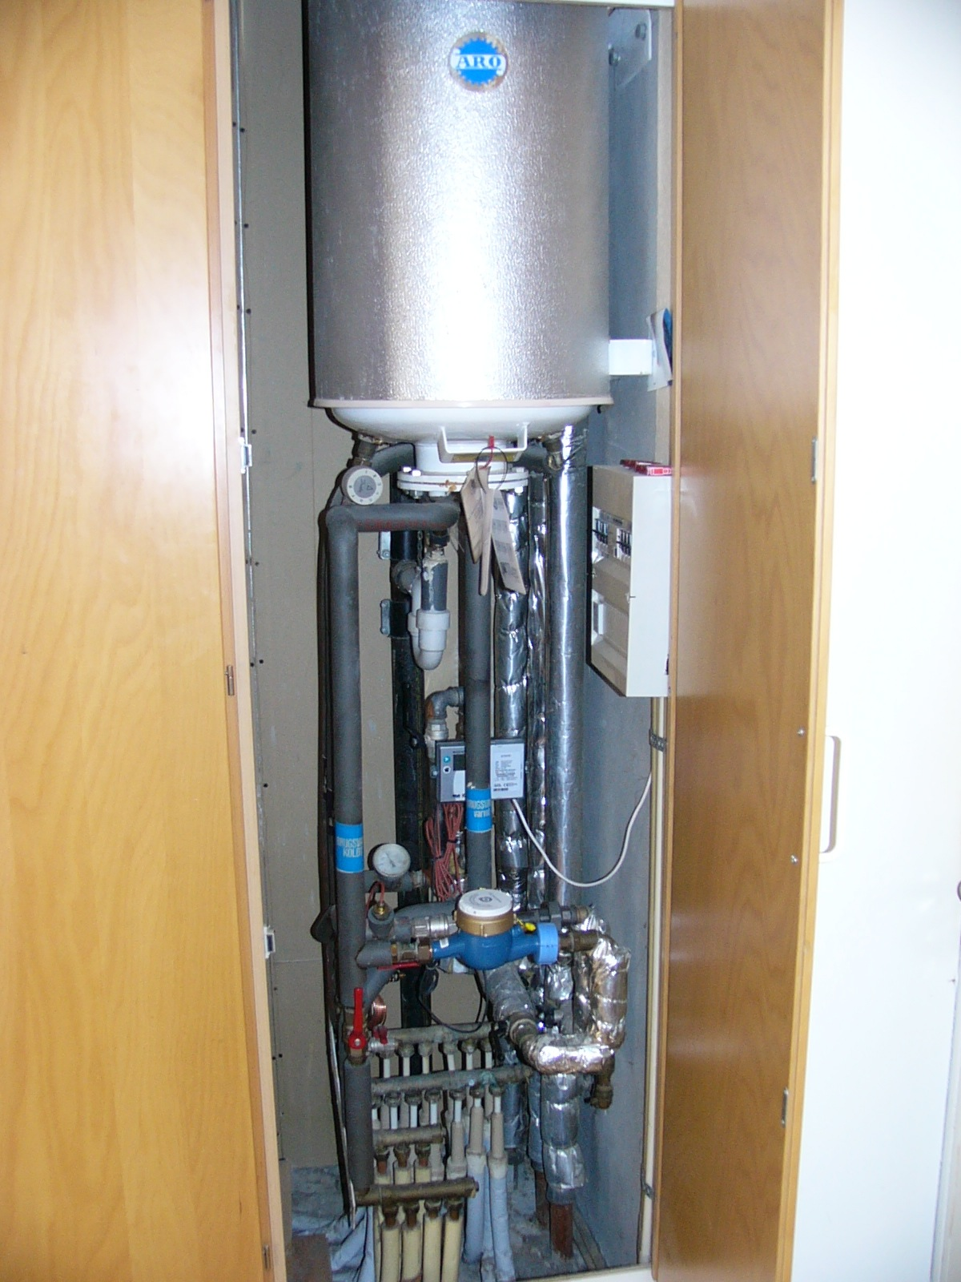
Lucky for me everything i gathered in one closet. First the hot water cylinder, the water from the district heating simply flows via a coil inside the cylinder. Cold comes in from the blue water meter and are split up in 2. one string directly to taps (via 1st manifold at bottom) and the other to bottom of cylinder and hot water comes out from the top and are split on the 2nd manifold at the bottom of the pic.

The Radiators are directly connected to district heating each with its own thermostatic valve. The district heating is split on the 2 manifolds in the back of the picture, one mani for in and one for out.

The meter with white lead to it is a multical 601 from Kamstrup, the water meter is an Elster M100 Artist meter.

Also not visible is a pressure differential valve that are used to keep pressure correct so that noise is kept to a minimum at high flow ect.

Now how am I going to use OpenTRV in my setup?

First the hotwater cylinder, its so good insulated that it can keep water at 70 degrees for 17 hours, at that time the temp has only dropped 8 degrees. Some would say its a waste to control this but keep in mind that the district heating is always flowing, maybe not much but every bit counts and 2 adults can take a shower after the 17 hours (even including a facewash half way).

So I will be replacing the valve for the hotwater cylinder from this:

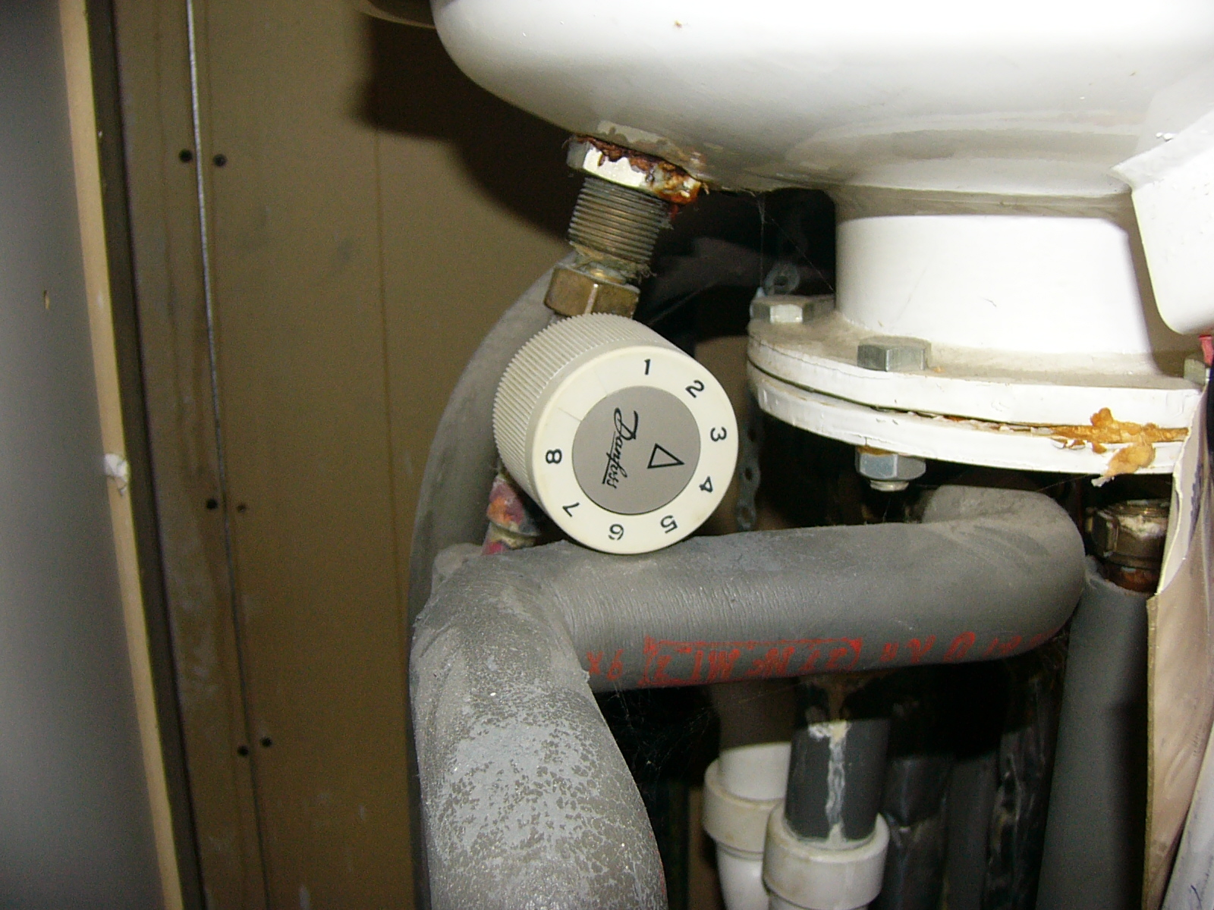

to this:

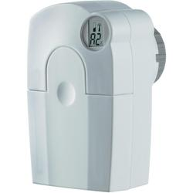

The old one has a single bolt that thightens arround the valve.

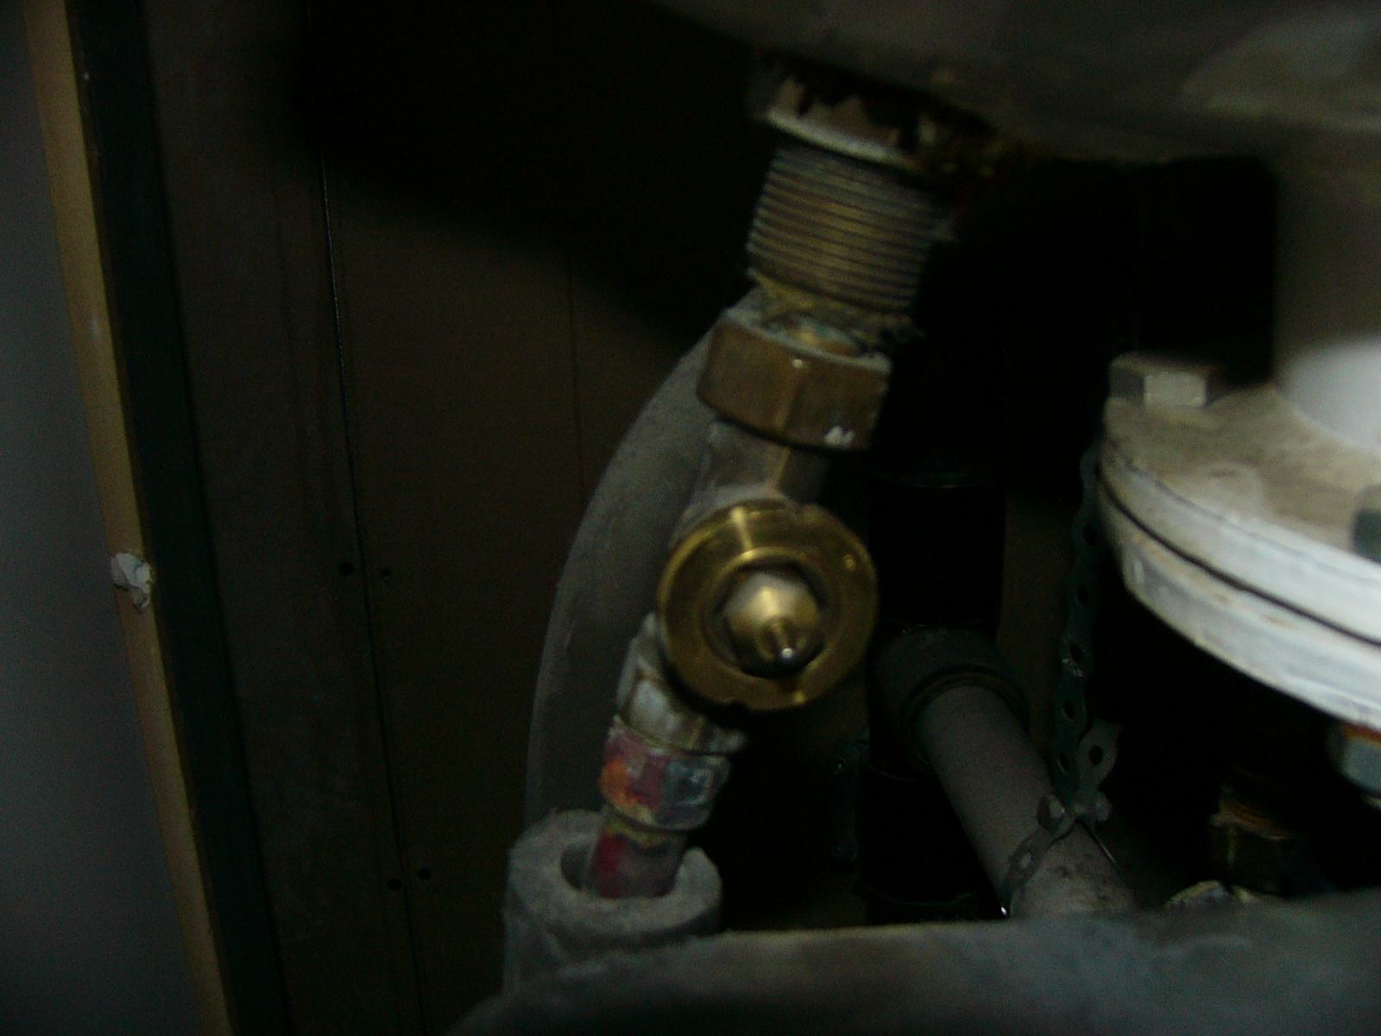
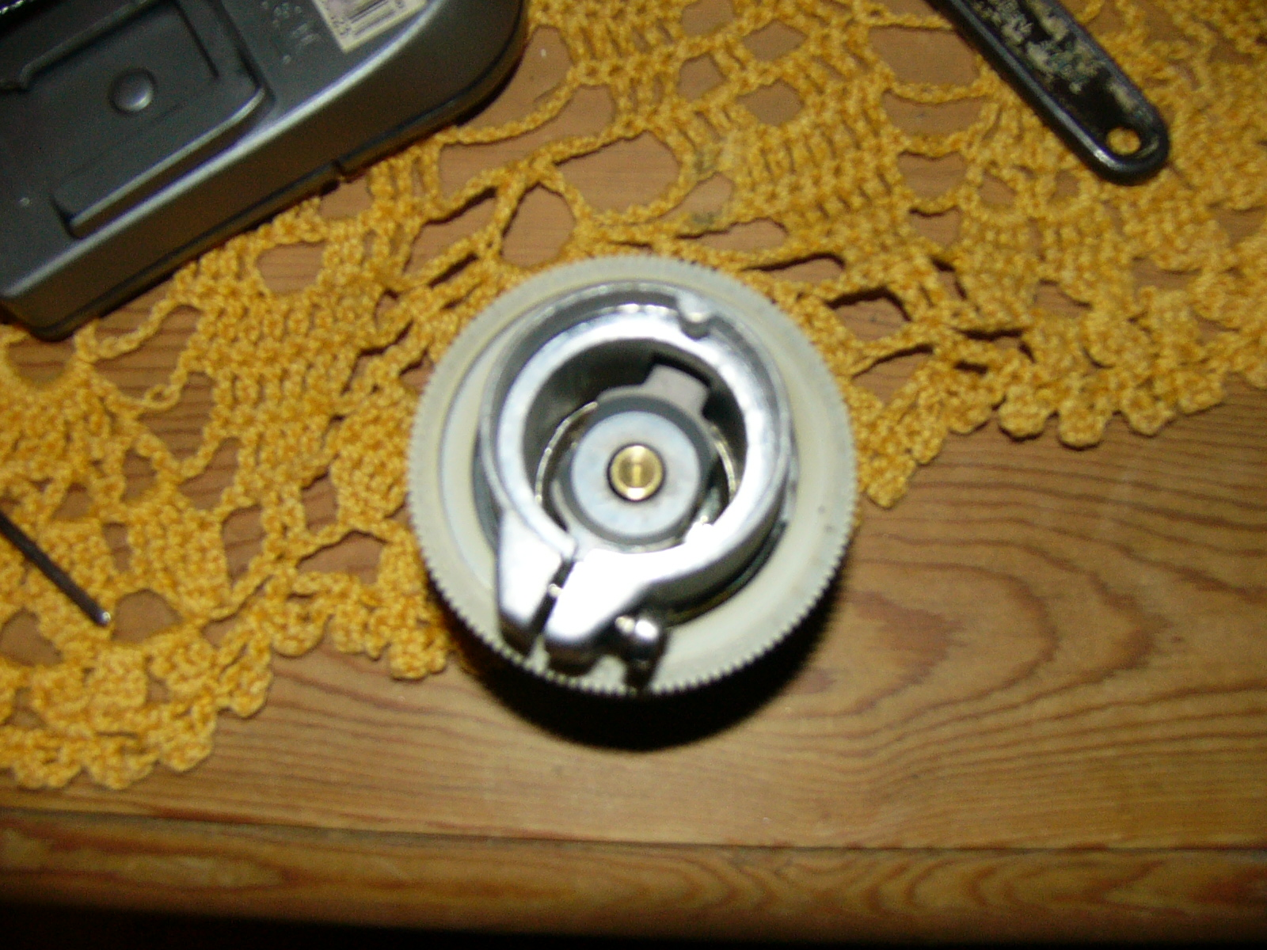
The wireless one are simply has a twist ring.

And then the gauge on the top of the cylinder:

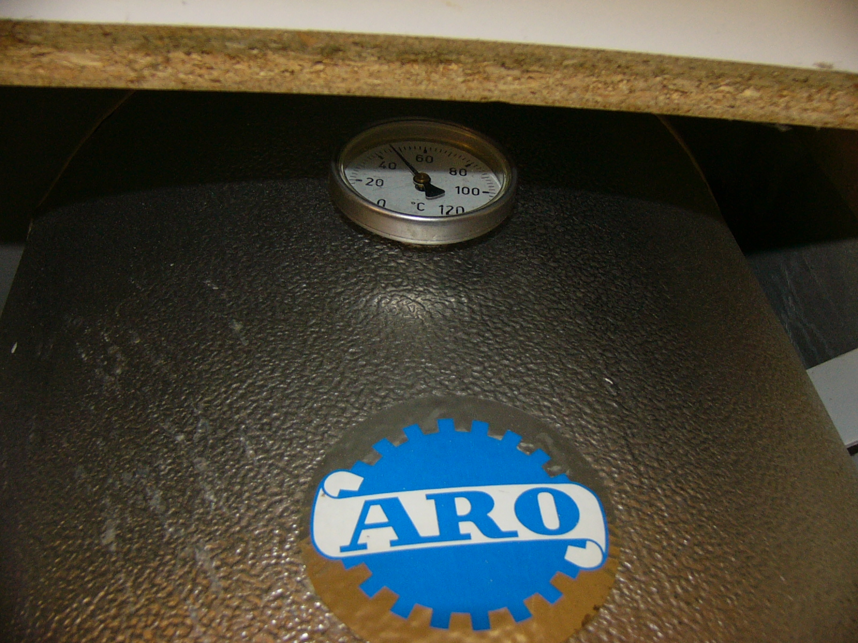
I will get one like it and hollow out the old one and insert a DS18B20 sensor. Put this back in the pocket (after filling in some thermal paste in the pocket).

To control it all I will use the OpenTRV controller that I have made in co-work with Mike and Damon. PCB looks like this (has as of writing not gone to pcb fab yet):

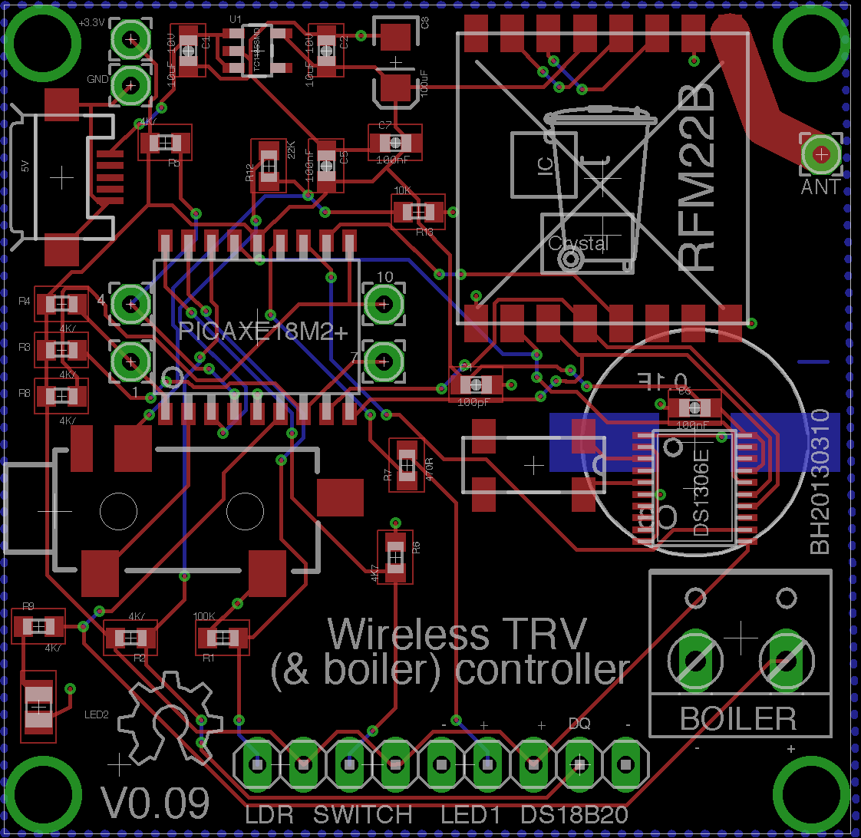

The program for the picaxe will be something like this: it will make sure we have at least 60 degrees water in the morning, by noon and by evening. At other times it shut the valve.

I might decide to go and fit hot water for our dishwasher and for that I have an idea of the dishwasher sending a signal to the controller that a big drain might be up, this could have the controller aim for 70 degrees and then go back to schedules heating...

With this the choices are as many as the ideas....

